Title: Habitat coupling across lakes-creek ecosystems: small fish as the missing link
Authors: Charlotte A. Ward¹*, Reilly F. O’Connor¹, Timothy J. Fernandes¹, Kevin S. McCann¹, Mark S. Ridgway³, Bailey C. McMeans⁴, Tyler D. Tunney^{2,1}
Affiliations:
- University of Guelph; Guelph, Canada
- Ontario Ministry of Natural Resources; Peterborough, Canada
- University of Toronto Mississauga; Mississauga, Canada
- Fisheries and Oceans Canada; Moncton, Canada

*Corresponding author:
Charlotte A. Ward; Address: 50 Stone Road East, Guelph, ON Canada, N1G 2W1;
Orchid ID: 0000-0001-7982-1239; Email: cward@uoguelph.ca
Target Journal: Oikos
Article Type: Research article
Main Text Word Count: 5865
Abstract Word Count: 196

Abstract
Habitat coupling has been an important area of freshwater research for more than two decades, yet studies on habitat coupling have primarily focused on large-bodied predators (e.g., lake trout, Salvelinus namaycush) due to their high mobility and importance for fisheries. Nevertheless, small fish at lower trophic levels can access narrow and shallow habitats, such as creeks adjacent to lakes, for foraging and refuge that are often inaccessible to larger-bodied organisms. Their movement across lake–creek boundaries is therefore expected to shape predator–prey dynamics and facilitate energy flow across freshwater landscapes. Despite this, the role of small fish in facilitating spatial food web linkages across whole freshwater landscapes remains underexplored. To address this gap, we developed a multi-method field approach combining stable isotope analysis, acoustic telemetry, and seasonal netting surveys to evaluate the habitat coupling of lakes and creeks by abundant prey fish species in Algonquin Park, the golden shiner (Notemigonus crysoleucas) and common shiner (Luxilus cornutus). Our findings reveal that prey fish seasonally couple lake and creek habitats, highlighting their role in establishing dynamic spatial food web linkages and underscoring the need to integrate small-bodied, lower-trophic level species into freshwater food web theory and management.

Introduction
The movement of consumer species across distinct habitats establishes critical energy linkages within food webs. At the global scale, the migrations of birds, fish, and mammals transport carbon and nutrients across vast distances, shaping productivity and nutrient dynamics far from their origins (Bauer & Hoye, 2014; Roman et al., 2025). On smaller scales, diel movements of zooplankton between benthic and pelagic zones of marine environments fuel their growth and reproduction (Cohen & Forward Jr, 2009). These movements play an integral role in sustaining biodiversity and stabilizing food webs (Rooney et al., 2008). Nevertheless, science and resource management are only beginning to integrate knowledge of consumer-driven energy linkages into the understanding of ecosystem resilience (i.e., the ability to maintain functions and recover from disturbances) amid rapid global change (Bartley et al., 2019).
The process through which mobile consumers link spatially explicit energy pathways through their movement and foraging behaviour is referred to as habitat coupling (Schindler & Scheuerell, 2002). In freshwater systems, research on habitat coupling has primarily been explored in the context of within-lake dynamics, such as the integration of nearshore and offshore energy pathways by fish that move between and forage among these distinct areas of lakes (Maitland et al., 2024; Tunney et al., 2014; Wegher et al., 2025). This process may support consumer populations in the face of environmental variability by allowing for opportunistic foraging in habitats with seasonally or stochastically higher productivity. In doing so, habitat coupling can help stabilize predator-prey interactions and enhance the resilience of whole lake food webs by supporting multiple energetic pathways that respond dynamically to changing conditions (McCann et al., 2005).
However, lakes are not isolated entities; they are embedded within broader freshwater landscapes and connected to adjacent creeks and streams. Unlike open-water areas of lakes, these narrow, shallow, and structurally complex habitats are often inaccessible to the large-bodied fish species that are known to establish cross-habitat energy linkages within lake food webs through their habitat coupling (e.g., lake trout Salvelinus namaycush, smallmouth bass Micropterus dolomieu, walleye Sander vitreus; Dolson et al., 2009; Maitland et al., 2024; Tunney et al., 2018). Further, emerging evidence suggests that small prey fish (e.g., smaller-bodied Leuciscidae species, early life stages of predators) move between and rely on different habitats just as extensively as their larger counterparts, but in fundamentally different ways. Small fish can exploit narrow and shallow creek habitats for refuge from predators and foraging opportunities (Brönmark et al., 2008; He and Kitchell, 1991). Consequently, the cross-habitat movements of small fish ought to shape prey accessibility for predators as well as the flow of energy across freshwater landscapes. Yet, habitat coupling and its consequences for freshwater food webs have seldom been considered in the context of small-bodied, lower-trophic-level fish, despite their critical roles as consumers of basal resources (e.g., algae, detritus; (Prejs, 1984)) and invertebrates (Champagne et al., 2022), and as key prey for economically and culturally important predators (Paterson et al., 2009). The coupling of lakes and their adjacent creeks and streams by small fish thus represents a missing link in our understanding of freshwater food webs and their resilience.
Over the past few decades, multiple biotracers have been developed that significantly enhance our ability to study the habitat use of fish and the structure of aquatic food webs. For instance, stable isotopes of carbon (¹³C/¹²C) and nitrogen (¹⁵N/¹⁴N) provide insight into the relative contribution of resources from distinct habitats and trophic levels to consumer tissue assimilation, allowing researchers to infer foraging patterns over multiple temporal scales based on the known turnover rates of different tissues (Fry, 2008). Acoustic telemetry, on the other hand, enables the fine-scale tracking of movement in real-time, revealing how individuals move between and use different habitats across different timescales (Blanchfield et al., 2023; Rodrigues et al., 2025). Traditional approaches such as netting surveys complement these tracers by providing snapshots of species richness, abundance, and biomass distributions across different habitats and, when repeated, how these metrics change over time (Portt et al., 2006). Together, these tools offer a powerful approach for assessing whether small fish couple lake and creek habitats and whether the degree of habitat coupling varies throughout the year.
In this study, we integrate stable isotope analysis, acoustic telemetry, and seasonal netting surveys to examine the foraging and habitat use of highly abundant prey fish species in Algonquin Park, Ontario. Specifically, we assess whether the golden shiner (Notemigonus crysoleucas) and common shiner (Luxilus cornutus) (1) use and forage among lake and creek habitats, thereby functioning as lake-creek habitat couplers, and (2) exhibit seasonal variation in the extent to which they couple lake and creek habitats (see Figure 1 for a conceptual representation of our approach). We examine seasonal patterns in habitat coupling as such variation would suggest that small fish adjust their behaviour to exploit fluctuations in biotic and abiotic characteristics of these habitats throughout the year, thus contributing to the resilience of freshwater ecosystems.

Methods

Study System
Data were collected in the southernmost bay of Lake Opeongo, Sproule Bay, and its adjacent Costello Creek, located within Algonquin Provincial Park, Ontario, Canada (Figure 2; study area: 45.50°N–45.85°N, 78.30°W–78.50°W). Lake Opeongo is a large, oligotrophic, dimictic lake with a surface area of 5154.2 ha and a maximum depth of 49.4 m (Ridgway et al., 2017). It is typically ice-covered from late November through April. Costello Creek is a tributary of the Upper Madawaska tertiary watershed and the Opeongo River quaternary watershed, and flows into Sproule Bay. The creek is characterized by shallow depths (<2 m) and moderate flow velocities (0.1–0.4 m s⁻¹). Previous research has identified two distinct habitat types in Costello Creek, a downstream portion dominated by a spruce bog with turbid, slow-moving water, and an upstream portion characterized by clear, fast-flowing water (Benoit et al., 2018).
Lake Opeongo supports a diverse fish community, including native species such as lake trout (Salvelinus namaycush), brook trout (Salvelinus fontinalis), lake whitefish (Coregonus clupeaformis), cisco (Coregonus artedi), white sucker (Catostomus commersonii), yellow perch (Perca flavescens), brown bullhead (Ameiurus nebulosus), burbot (Lota lota), and various leuciscid species, including golden shiner (Notemigonus crysoleucas), common shiner (Luxilus cornutus), creek chub (Semotilus atromaculatus), and bluntnose minnow (Pimephales notatus). The lake also contains introduced smallmouth bass (Micropterus dolomieu), stocked outside their native range during early 20th-century fishery management efforts, where they have since established abundant populations (Jackson, 2002). Costello Creek shares many of these species, along with additional members of the Leuciscidae family, such as brassy minnow (Hybognathus hankinsoni), blacknose shiner (Notropis heterolepis), northern pearl dace (Margariscus margarita), finescale dace (Chrosomus neogaeus), fathead minnow (Pimephales promelas), longnose dace (Rhinichthys cataractae), and northern redbelly dace (Chrosomus eos).
In this study, we focus on two prey fish species from the Leuciscidae family, golden shiner (Notemigonus crysoleucas) and common shiner (Luxilus cornutus). These species were captured in high abundances across both lake and creek habitats throughout the three-year study period, enabling comparisons of their isotopic signatures across habitats and seasons. They also occupy similar functional roles within freshwater ecosystems, primarily consuming basal resources and primary consumers (and are not typically piscivorous at any size class; Scott & Crossman, 1973; Stone et al., 2016), allowing us to combine data from both species to evaluate habitat use of lakes and creeks.
All sampling and surgical implantation procedures for acoustic telemetry described in the following subsections were authorized by a license to collect fish for scientific purposes from the Ontario Ministry of Natural Resources (#1103418), authorization to conduct research in an Ontario provincial park, and an animal use protocol approved by the DFO Maritimes & Gulf / HMSC Regional Animal Care Committee (#23-11, #24-22) under Canadian Council on Animal Care guidelines.

Foraging Behaviour
We employed stable isotope analysis to quantify habitat-specific resource use (foraging) by shiners across the spring, summer, and fall of 2022–2024. We used liver tissues, as liver has a relatively fast turnover rate (approximately two weeks) and thus more accurately reflects diets during the season of sampling compared to slower-turnover tissues like muscle (Busst & Britton, 2018). Spring sampling was conducted approximately two weeks after ice-off each year (late April to early May), summer sampling during the first and second weeks of August and fall sampling during the first and second weeks of October. We aimed to collect a minimum of 10 individual fish of each species from each habitat per season whenever possible. Across all years and seasons, we obtained liver samples from 134 golden shiners and 117 common shiners. Due to the fact that lake-caught shiners were difficult to capture during summer and liver extraction from these small-bodied fish was occasionally unsuccessful, only two liver samples were available for this group. To allow calculation of summary statistics for comparison with other groups, one additional summer lake-caught individual was included using muscle tissue. However, muscle tissue has a known slower isotopic turnover rate than liver, so this substitution should be interpreted with caution. In addition to fish tissue samples, tissue samples were collected from unionid mussels (Elliptio sp.) and mayflies (Ephemeroptera sp.) to estimate baseline isotopic signatures in lake and creek habitats.
Samples were frozen immediately after field capture and stored at –20°C until dissection and preparation for stable isotope analysis. Thawed fish tissue and baseline samples were placed in a drying oven at 60°C for 48–72 hours and then ground into a powder. Samples were sent to the Jan Veizer Stable Isotope laboratory at the University of Ottawa for quantification of δ¹³C and δ¹⁵N. Stable isotope values are expressed in δ notation (units ‰), where δ¹³C or δ¹⁵N = ((Rsample/Rstandard) – 1) x 1000, where R represents the ratio of ¹³C/¹²C or ¹⁵N/¹⁴N.
We applied lipid corrections to consumer and baseline tissues following Kiljunen et al. (2006) because C:N ratios exceeded the recommended threshold of 3.5 across our dataset (Post, 2007). Given ongoing debate over the application of lipid normalization in ecological stable isotope studies (Arostegui et al., 2019), we repeated our analyses using non–lipid-corrected values and found qualitatively similar patterns to those presented in the proceeding sections (Appendix S1; Figure S2).
Data Analysis
To evaluate the foraging behaviour of shiners captured across lake and creek habitats seasonally, we calculated the proportion of lake-derived carbon in each fish’s liver tissue using a two-source δ¹³C mixing model (Post, 2002). Each consumer’s δ¹³C value was interpolated between the mean δ¹³C of creek and lake mayfly baselines according to Equation 1, and estimates were constrained between 0 and 1. Trophic position was then estimated for each individual using a habitat-weighted δ¹⁵N approach (Post, 2002), where the expected baseline δ¹⁵N was calculated as a weighted average of the creek and lake mayfly δ¹⁵N values, weighted by the individual’s estimated proportion of lake-derived carbon, and a trophic fractionation factor of 3.4‰ per trophic level was assumed (Equation 2).
$Proportion lake derived carbon (α)=\frac{δ^{13}C_{consumer}-δ^{13}C_{creek }}{δ^{13}C_{lake}-δ^{13}C_{creek}}$ (1)
$Trophic Position =2+\left[α\frac{δ^{15}N_{consumer}-δ^{15}C_{creek}}{3.4}+ \left(1-α\right)\frac{δ^{15}N_{consumer}-δ^{15}C_{lake}}{3.4}\right]$ (2)
Differences in isotopic composition and derived isotopic metrics of shiners (proportion of lake derived carbon and trophic position) were analyzed using generalized linear models in R version 4.4.0. For raw isotope values, separate Gaussian generalized linear models were fitted for liver δ¹³C and δ¹⁵N, with season, capture location, and their interaction included as fixed effects. The proportion of lake-derived carbon was analyzed using a generalized linear model with a quasibinomial error distribution and logit link for proportional data, while trophic position was analyzed using a Gaussian generalized linear model. All models included season, capture location, and their interaction as fixed effects. Significance of model terms was assessed using Type III analysis of deviance with the car package (Fox et al., 2026). When interactions were significant, post hoc comparisons were conducted using estimated marginal means from the emmeans package (Lenth et al., 2026), with Tukey-adjusted pairwise comparisons among seasons within each location and between locations within each season.

Habitat Use and Movement
Acoustic telemetry was used to track the habitat use and movement of shiners between the lake and creek. Due to a limited number of tags and to minimize variability in movement patterns across species, tagging efforts focused exclusively on golden shiners (Notemigonus crysoleucas). A total of 45 individuals were surgically implanted with acoustic transmitters (V6-180 kHz; Innovasea, Halifax, Nova Scotia). Transmitters measured 15 mm in length, 6 mm in diameter, weighed 0.5 g in water, and emitted at ~146 dB. Each transmitter carried a unique identifier and was programmed with one of three nominal ping interval ranges. 10 fish received tags with slower intervals of 130–230 s, 5 fish received faster tags with intervals of 33–57 s, and the majority (30 fish) received tags with intermediate intervals of 80–160 s. Tagged shiners averaged 154 ± 10 mm in total length and 35 ± 8 g in weight, with transmitters representing ≤ 2% of body mass in water.
Fish were captured with trap nets and held in aerated lake water for approximately 15 minutes prior to surgery. Anesthesia was induced in buffered MS-222 (100 mg L⁻¹) until loss of equilibrium and no response to caudal pinch. During surgery, fish were placed in a cradle lined with nylon mesh and irrigated over the gills with maintenance anesthetic (45 mg L⁻¹). A 6–8 mm ventral midline incision anterior to the pelvic girdle was made, and transmitters were inserted into the intracoelomic cavity. Incisions were closed with 1–2 surgical sutures using 5-0 absorbable monofilament. Instruments were disinfected with 10% povidone-iodine prior to each surgery. Surgeries lasted ~3-6 min, and fish typically recovered in aerated tanks within 10–20 min, at which point they were released at their site of capture once normal posture and swimming were observed.
The receiver array consisted of 30 omnidirectional Innovasea receivers (VR2W, 69 kHz) deployed to cover the interface of Sproule Bay and Costello Creek (Figure 2). Receivers were moored 1–2 m above the lake or creek bottom with subsurface floats and anchors and were positioned to provide overlapping coverage across the habitat boundary. Receivers were inspected and serviced in September 2023 prior to the start of telemetry monitoring. Range tests were conducted on two receivers per habitat to determine detection range in the different locations. To evaluate detection range in different habitats, drift tests were conducted on two receivers in each habitat type, including the transition zone between the lake and creek. On average, receivers in the lake detected transmitters at distances up to ~200 m, those in the creek up to ~65 m, and those in the transition zone up to ~100 m. When transmitters were placed directly within dense vegetation or behind creek meanders, detections were not made, indicating that detection probability was generally higher for fish occupying lake habitats than creek habitats.
Raw detections were filtered to remove false codes and duplicates (<60 s apart for the same fish). Analyses were restricted to fish detected post-release (n = 37). Additionally, two tagged individuals that remained within detection range of a single receiver for the duration of their detection history were excluded from the final dataset, as this pattern is consistent with post-release mortality (Klinard and Matley, 2020; transmitter id #1594949 and #1576137 shown in abacus plot in Supplementary Materials; Figure S5). For the remaining fish (n = 45), enriched time series were constructed from the tag-on date, offset by one day to account for variation in release timing, to the tag-off date, which reflected battery life and any “on/off” cycles of transmitters. To generate continuous time series for fish with active tags, we constructed an enriched minute-level time series in which a fish’s last known location was carried forward if no detection occurred during a given minute, but the fish’s tag was active. This approach is used to reduce gaps in movement datasets (Brownscombe et al., 2023) and was justified here by the close placement of receivers along the lake–creek boundary, which ensured that cross-boundary movements would be captured (Laroque et al., 2024). This enriched time series is shown for all transmitters through time (Supplementary Materials S1; Figure S6).
Data Analysis
To characterize habitat use, we calculated two telemetry-based metrics for each individual within each season: lake residency and habitat recurrence. Lake residency was defined as the proportion of detected minutes within a season during which an individual was inferred to be in the lake, calculated as the number of minutes assigned to the lake divided by the total number of detected minutes in that season. Habitat recurrence quantified the number of discrete return events to an individual’s initial detected habitat, defined as cases in which a fish was first detected in one habitat, subsequently exited that habitat, and was later detected there again. Seasons were defined as spring (March 21 to June 20), summer (June 21 to September 20), fall (September 21 to December 20), and winter (December 21 to March 20). Winter data were excluded from analyses presented in Figure 3 to maintain consistency with the stable isotope dataset, which did not include winter sampling.
Seasonal differences in lake residency were analyzed using a generalized linear model with a quasibinomial error distribution and logit link. The response was modeled as the number of lake-assigned minutes relative to the number of non-lake minutes using a two-column response of lake minutes and total minutes minus lake minutes. Season, release location, and their interaction were included as fixed effects. Seasonal differences in habitat recurrence were analyzed using a negative binomial generalized linear model, with total recurrence events as the response and season, release location, and their interaction as fixed effects. These distributions were selected because lake residency represented proportional data and recurrence was count data with many zero observations. Significance of model terms was assessed using Type III analysis of deviance with the car package (Fox et al., 2026), and post hoc comparisons were conducted using estimated marginal means from the emmeans package with Tukey-adjusted pairwise tests (Lenth et al., 2026).
We also used generalized additive mixed models (GAMMs) from the mgcv package in R with a binomial family and logit link, which allowed us to flexibly model non-linear seasonal patterns (Wood, 2017). Models were fitted to evaluate the probability of fish being detected in both lake and creek habitats throughout the year (i.e., being detected at receivers in both habitats on the same day). Day of year (Julian date), our key explanatory variable of interest to assess seasonal habitat use, was included as a fixed effect with a cubic spline (k = 10) to capture the cyclic nature of seasonality. We also included total length as a covariate (fixed effect), and random intercepts for fish ID and release location to account for individual variation and the potential influence of different release sites. To address temporal autocorrelation inherent in repeated detections, we incorporated a first-order autoregressive correlation structure (corAR1) into all models. Comparisons of five candidate models were based on Akaike Information Criterion (AIC), with the model yielding the lowest AIC considered the most parsimonious (Table 1).

Biomass Flux
Trap nets were set across the width of Costello Creek at two locations, one at the mouth of the creek and the other approximately two kilometers upstream. At the mouth, two small-mesh (4mm) fyke nets with an opening size of 39x39 inches were deployed. The nets were set with the lead lines blocking the creek, ensuring that fish moving upstream were captured in one net, while fish moving downstream were intercepted by the other. At the upstream location, a custom-made trap net was used, measuring 27 inches in height, 23.5 inches in width, and 36.5 inches in length. The trap was designed with two compartments, one facing upstream and the other facing downstream. To block the entire width of the creek, large block nets (small mesh; 4mm) were placed on each side of the trap. Fish moving upstream were captured in the upstream-facing compartment and released further upstream after processing, while those moving downstream were captured in the downstream-facing compartment and released further downstream after processing.
Traps were set for five consecutive days (trap net set for 24 hours before sampling) during the spring, summer, and fall of 2023, and for three consecutive days in 2024. Each morning, fish were removed from the traps, and the number, weight, total length, and fork length of at least 30 individuals per day per species were recorded. After the first 30 fish were measured, bulk weights of each species were recorded among the remainder of fish in each compartment of the trap. To calculate directional biomass flux, we took the mean ± SD of total biomass of golden and common shiners captured in each compartment of the trap per day per season.
Additionally, standardized surveys were conducted using minnow traps at 10 sites in the creek and 10 sites in the lake. We set minnow traps overnight (12-hour sets) and removed all fish from traps the following morning, recording species names, weight, total length, and fork length for each individual. Habitat-specific biomass was calculated as average biomass (mean ± SE) of golden and common shiners per trap, per habitat, and per season.
Data Analysis
Differences in the average daily biomass of shiners captured in directional traps (upstream vs. downstream biomass flux) and seasonal shiner biomass captured using minnow trap surveys in the lake and creek were each evaluated using separate two-way ANOVAs and Tukey HSD post hoc comparisons, with season and direction (or habitat) as fixed factors including their interaction term. Biomass data were log-transformed prior to analysis to meet the assumptions of normality and homogeneity of variance, which were confirmed using Shapiro-Wilk tests on model residuals and Levene’s tests, respectively.

Results

Stable Isotope Ratios
Baseline organisms differed strongly in isotopic composition between habitats (Figure 2) and, in some cases, also showed seasonal variation. Mayflies from creek habitats had substantially more depleted δ¹³C values than mayflies from the lake (habitat: χ² = 109.77, p < 0.001). The effect of season on δ¹³C of mayflies was not significant (χ² = 0.68, p = 0.71), but a significant season x location interaction was observed (χ² = 7.90, p = 0.019), reflecting seasonal shifts within lake mayflies where δ¹³C values were more enriched in summer relative to spring (p = 0.008). Mayfly δ¹⁵N values varied significantly with both season (χ² = 18.21, p < 0.001) and habitat (χ² = 67.65, p < 0.001), with creek mayflies consistently enriched relative to lake mayflies in all seasons (Spring: Δ = 0.95‰, p < 0.001; Summer: Δ = 1.58‰, p < 0.001; Fall: Δ = 2.29‰, p < 0.001). Seasonal variation was strongest within lake mayflies, where δ¹⁵N declined from spring to summer (p < 0.001), while creek values remained relatively stable across seasons except for slightly higher values in fall relative to summer (p = 0.012).
Mussel δ¹³C differed significantly between habitats (χ² = 32.43, p < 0.001), with creek mussels consistently more depleted than lake mussels across seasons (Spring: Δ = −1.84‰, p = 0.0006; Summer: Δ = −2.86‰, p < 0.001; Fall: Δ = −2.50‰, p = 0.013). Neither season (χ² = 2.20, p = 0.33) nor the season x habitat interaction (χ² = 1.78, p = 0.41) significantly influenced mussel δ¹³C. Similarly, mussel δ¹⁵N varied across habitats (χ² = 226.28, p < 0.001), with creek mussels consistently enriched relative to lake mussels in all seasons (Spring: Δ = 2.70‰, p < 0.001; Summer: Δ = 3.32‰, p < 0.001; Fall: Δ = 3.08‰, p < 0.001). In contrast, seasonal effects were not significant for δ¹⁵N (χ² = 2.78, p = 0.25), and no season x habitat interaction was detected (χ² = 2.90, p = 0.24).
Raw shiner isotope values also varied across habitats. Common shiners had mean liver δ¹³C values of -29.1 ± 1.56 in the creek and -27.7 ± 2.38 in the lake, with corresponding δ¹⁵N values of 5.45 ± 0.67 and 5.36 ± 0.60. Golden shiners showed a similar pattern, with creek-caught individuals averaging -29.6 ± 1.35 for δ¹³C and 5.67 ± 0.71 for δ¹⁵N, compared with -27.7 ± 1.63 and 5.33 ± 0.77 for lake-caught individuals. Gaussian generalized linear models revealed significant effects of season, capture location, and their interaction (Type III analysis of deviance: season, χ² = 22.49, df = 2, p < 0.001; location, χ² = 70.54, df = 1, p < 0.001; season x location, χ² = 37.39, df = 2, p < 0.001). Liver δ¹⁵N also varied with location of capture, although patterns were weaker than for δ¹³C. The Gaussian generalized linear model showed a significant effect of capture location and a significant season x location interaction, but only a marginal overall effect of season (season, χ² = 4.98, df = 2, p = 0.083; location, χ² = 10.81, df = 1, p = 0.001; season x location, χ² = 7.60, df = 2, p = 0.022).

Foraging Behaviour
The proportion of lake-derived carbon in shiner liver tissues varied strongly across season and capture locations (Figure 3A). The quasibinomial generalized linear model detected significant effects of season, capture location, and their interaction (season, χ² = 24.13, df = 2, p < 0.001; location, χ² = 65.52, df = 1, p < 0.001; season x location, χ² = 38.28, df = 2, p < 0.001). Creek-captured shiners had moderate estimated reliance on lake-derived carbon in spring (0.493 ± 0.022), lower reliance in summer (0.335 ± 0.026), and similar values again in fall (0.479 ± 0.027). Tukey-adjusted comparisons confirmed that summer values were lower than both spring and fall in creek-captured fish, while spring and fall did not differ. In contrast, lake-captured shiners showed higher reliance on lake-derived carbon in summer (0.895 ± 0.071) and fall (0.851 ± 0.042) than in spring (0.582 ± 0.025), with no difference between summer and fall. Comparisons between locations within seasons showed that lake-captured shiners had higher lake-derived carbon than creek-captured shiners in spring, summer, and fall. The seasonal difference between lake and creek fish was modest in spring (Δ = +0.089) but much larger in summer (Δ = +0.560) and fall (Δ = +0.372). Summer estimates for lake-captured fish should be interpreted cautiously because that group included only three individuals.
Trophic position also depended on the interaction between season and capture location (Figure 3B). The Gaussian generalized linear model indicated significant effects of season, capture location, and their interaction (season, χ² = 13.81, df = 2, p = 0.001; location, χ² = 40.59, df = 1, p < 0.001; season x location, χ² = 25.36, df = 2, p < 0.001). Creek-captured shiners maintained relatively consistent trophic positions across seasons, with means of 3.03 ± 0.024 in spring, 3.11 ± 0.031 in summer, and 3.05 ± 0.031 in fall; none of these seasonal contrasts were significant after Tukey adjustment. Lake-captured shiners, however, had lower trophic positions in summer (2.55 ± 0.126) and fall (2.74 ± 0.054) than in spring (2.98 ± 0.026). Pairwise comparisons showed that trophic position did not differ between creek- and lake-captured shiners in spring, but creek-captured shiners occupied significantly higher trophic positions than lake-captured individuals in summer and fall. The magnitude of this difference was greatest in summer (Δ = -0.563 for lake minus creek) and remained substantial in fall (Δ = -0.312).

Habitat Use and Movement
Lake residency varied little across seasons but differed by release location. The quasibinomial generalized linear model detected no effect of season (χ² = 0.93, df = 2, p = 0.627) and no season x release location interaction (χ²= 4.48, df = 2, p = 0.106), but did detect a significant main effect of release location (χ² = 4.49, df = 1, p = 0.034). Across seasons, lake-released fish generally exhibited higher estimated lake residency than creek-released fish, although pairwise comparisons within individual seasons were not significant after Tukey adjustment. Estimated mean lake residency for creek-released fish was 0.669 (95% CI: 0.469 to 0.821) in spring, 0.465 (95% CI: 0.294 to 0.645) in summer, and 0.740 (95% CI: 0.514 to 0.884) in fall. For lake-released fish, corresponding values were 0.782 (95% CI: 0.413 to 0.948), 0.992 (95% CI: 0.036 to 1.000), and 0.747 (95% CI: 0.221 to 0.969). Descriptive summaries showed a similar pattern, with mean lake residency ranging from 0.611 ± 0.104 to 0.690 ± 0.081 for creek-released fish and from 0.754 ± 0.151 to 0.967 ± 0.033 for lake-released fish, although uncertainty was high for some lake-release groups because of small sample sizes.
Habitat recurrence showed strong seasonal variation and also differed by release location. The negative binomial generalized linear model revealed significant effects of season (χ² = 21.36, df = 2, p < 0.001) and release location (χ² = 6.03, df = 1, p = 0.014), but no season x release location interaction (χ² = 1.35, df = 2, p = 0.509). For creek-released fish, recurrence was much higher in spring and fall than in summer. Estimated recurrence was 11.33 events (95% CI: 5.01 to 25.63) in spring, 1.14 (95% CI: 0.55 to 2.36) in summer, and 8.82 (95% CI: 3.74 to 20.78) in fall. Tukey-adjusted comparisons confirmed that spring recurrence exceeded summer recurrence (ratio = 9.92, p = 0.0001) and that fall recurrence also exceeded summer recurrence (ratio = 7.72, equivalently summer/fall ratio = 0.130, p = 0.001), while spring and fall did not differ. A similar seasonal pattern occurred for lake-released fish, with recurrence highest in spring (6.25, 95% CI: 1.48 to 26.31), very low in summer (0.14, 95% CI: 0.02 to 1.32), and intermediate in fall (1.75, 95% CI: 0.36 to 8.40). In this group, spring recurrence was significantly greater than summer recurrence (ratio = 43.75, p = 0.014), whereas the other seasonal contrasts were not significant.
Although recurrence differed overall by release location, pairwise contrasts within individual seasons were not statistically significant after Tukey adjustment. Still, descriptive summaries suggested that creek-released fish tended to exhibit more recurrence events than lake-released fish, especially in summer and fall. Mean recurrence for creek-released fish was 11.3 ± 4.7 in spring, 1.1 ± 0.4 in summer, and 8.8 ± 3.9 in fall, compared with 6.2 ± 4.6, 0.1 ± 0.2, and 1.8 ± 1.4 for lake-released fish. Overall, these results indicate that repeated habitat returns were most common in spring and fall and were strongly reduced during summer, while lake residency itself remained relatively stable across seasons.
A significant seasonal pattern also emerged in the probability that a tagged fish was detected in both the lake and the creek on a given day (Figure 4). This pattern was best captured by a generalized additive mixed model including a cyclic smoother for day of year and an autoregressive correlation structure (corAR1) within individuals (Table 1). The selected model explained approximately 10% of the deviance in detection probability (R²_{adj} = 0.097) and revealed a significant effect of day of year (edf = 6.75, F = 8.13, p < 0.001). From this model, estimated probabilities of a fish being detected in both lake and creek habitats peaked at 0.422 (95% CI: 0.298–0.556) on Julian day 107 (spring), with a secondary peak at 0.262 (95% CI: 0.176–0.371) on Julian day 299 (fall), and a pronounced minimum of 0.015 (95% CI: 0.005–0.042) on Julian day 223 (summer). Models that additionally included fish total length or random intercepts for release location did not improve model fit (ΔAIC ≥ 2; Table 1).

Biomass Flux
The average daily biomass of shiners captured in directionally positioned traps within the creek showed strong seasonal differences in both the magnitude and direction of biomass flux (Figure 5A). A two-way ANOVA on log-transformed biomass data revealed a significant difference in biomass flux across seasons (p < 0.001) and a significant season–direction interaction (p = 0.0013), while direction alone was not significant (p = 0.18). In the spring, upstream flux was significantly greater than downstream flux, with 3205.5 ± 1156.6 g of shiner biomass moving upstream per day compared to 752.2 ± 304.8 g moving downstream (p = 0.0017). In the summer, biomass flux was low overall, with 212.4 ± 51.2 g upstream and 118.8 ± 26.9 g downstream, and no significant difference between directions (p = 0.44). In the fall, downstream flux was significantly greater than upstream flux, with 1629.2 ± 349.2 g moving downstream compared to 464.6 ± 86.3 g moving upstream (p = 0.025). Together, these results indicate seasonal shifts in biomass flux within the creek, with dominant upstream movement in spring and dominant downstream movement in fall.
The biomass of shiners captured using minnow traps also showed strong seasonal and habitat-specific differences (Figure 5B). In the creek, biomass was highest in spring (279.1 ± 71.8 g), declined in summer (133.3 ± 35.9 g), and was lowest in fall (25.6 ± 5.4 g). In the lake, biomass was much lower overall, with 40.8 ± 9.1 g in spring and 55.8 ± 11.4 g in fall; no shiners were captured in lake traps during summer. A two-way ANOVA on log-transformed biomass data confirmed a significant season x habitat interaction (p = 0.022). Post-hoc comparisons revealed that in spring, creek biomass was significantly greater than lake biomass (p = 0.012), while in fall there was no difference between habitats (p = 0.38). Within the creek, biomass was higher in spring than fall (p = 0.045) but did not differ between spring and summer (p = 0.67). Within the lake, spring and fall did not differ significantly (p = 0.34), and no summer comparisons were made due to the absence of shiners captured during summer.

Discussion
Our results demonstrate that small-bodied prey fish couple lake and creek habitats through their resource use and movement behaviour, and that the strength of this coupling varies across seasons. Stable isotope analysis revealed that shiners relied more evenly on resources from the lake and creek in spring and fall, but relied more strongly on resources from the habitat in which they were captured during summer (Figure 3A). Acoustic telemetry showed a similar seasonal pattern in movement behaviour, where the probability of detecting a shiner in both habitats on the same day was highest in spring and fall (Figure 4), and movement between habitats was also greatest during these periods (Figure 3D). Netting surveys further supported this observation, with upstream biomass flux peaking in spring and downstream flux peaking in fall, and minimal flux occurring during summer (Figure 5B).
Several mechanisms may drive prey fish to move and forage between lake and creek habitats. Although we did not explicitly examine these drivers, our data suggest that multiple factors could be at play. First, the use of streams and creeks for spawning is common among many freshwater and marine species (Geist & Dauble, 1998; Gibson, 1993; Roberge et al., 2002). Our results indicate this may be an important contributor to lake–creek coupling among golden and common shiners, as we observed very high upstream biomass flux during spring, which coincides with spawning for both species (Lane et al., 1996; Stone et al., 2016). However, this period also showed a greater number of cross-habitat recurrence events from our telemetry data, suggesting fish were not moving upstream to spawn and then remaining in the creek, but were moving back and forth between habitats at this time of year. Additional factors therefore likely contribute to the coupling of lakes and creeks by small fish.
Research on lake–stream migrations among prey fish in European freshwater systems has shown that movements into streams adjacent to lakes are driven by trade-offs between growth opportunities and predation risk (Brodersen et al., 2008; Brönmark et al., 2008; Chapman et al., 2012). In these systems, seasonal migrations allow prey fish to occupy lower-risk stream habitats that are inaccessible to predatory fish when resources are scarce, and re-enter predator-dense lakes when resources are abundant. Such trade-offs between resource acquisition and predator avoidance also may contribute to the coupling of lake and creek habitats observed here.
Smallmouth bass (Micropterus dolomieu) are widespread, introduced predators that occupy both Lake Opeongo and Costello Creek. However, their size distributions differ markedly between habitats (Supplementary Materials S1; Figure S3), with individuals in the lake observed to be substantially larger (mean total length = 256 ± 123 mm) than those in the creek (mean total length = 112 ± 35 mm). Given established relationships between body size and piscivory (Mittelbach & Persson, 1998), smallmouth bass in the lake are expected to exert strong top-down pressure on prey fish such as shiners (Vander Zanden et al., 1999), whereas the smaller individuals in the creek are less likely to be piscivorous due to gape limitation (Mittelbach & Persson, 1998). Further, smallmouth bass collected from both habitats appeared to rely heavily on lake-derived sources (Supplementary Materials S1; Figure 43), indicating their primary role as predators within the lake. Although lake trout (Salvelinus namaycush) also inhabit Lake Opeongo, they were not observed in Sproule Bay or Costello Creek during our study and are unlikely to be major predators of shiners in this part of the system. Brook trout (Salvelinus fontinalis) were captured in the creek during spring and fall, but at sizes not typically associated with piscivory (<250 mm; Supplementary Materials S1; Figure S3), suggesting they exert relatively weak predation pressure on shiners (East & Magnan, 1991). Taken together, these findings suggest that large, lake-resident smallmouth bass are the dominant predators shaping prey vulnerability, and that access of these larger, more piscivorous individuals is limited in the creek.
This spatial context of predation risk may help explain the observed differences in body size among shiners across the study system. Both golden and common shiners captured in the creek were smaller on average than those captured in the lake throughout the study period (Supplementary Materials S1; Figure S3). Minnow trap surveys also failed to capture shiners in the lake during summer (Figure 4.5b), when smallmouth bass activity is highest (Bloomfield et al., 2022). However, two shiners from the largest size class (139 and 143 mm total length; TL) were caught with alternative gear, and both exceeded the maximum prey size predicted for the largest bass captured in our study (505 mm; Gaeta et al., 2018). Further, acoustic telemetry indicated that tagged shiners largely remained in the lake during summer (Figure 4.4b). This pattern likely reflects a tagging bias, because only larger individuals could be tagged, with a minimum size of 138 mm TL. These larger individuals may therefore be capable of persisting in the lake during summer, whereas smaller size classes may be more creek resident during this period to avoid predation by bass. We also found that winter was marked by reduced cross-habitat movement (Figure 4.4a). This result may reflect low activity at temperatures below the thermal preference of shiners (Hasnain et al., 2010; Frenette et al., 2019) along with the concurrent decline in bass activity at cold temperatures (Bloomfield et al., 2022). Together, these constraints may lessen both the capacity for movement and the risk of predation during winter in the lake, prompting shiners to remain more lake resident during this time of year.
The seasonal nature of lake–creek coupling observed here has important implications for the resilience of freshwater food webs. By shifting their habitat use in response to changing seasonal conditions (e.g., predation risk or resource availability), prey fish may access complementary resource pools when one habitat becomes less favourable. This behavioural flexibility can mediate predator–prey encounter rates and distribute foraging pressure across time and space. In doing so, it may help dampen strong, potentially destabilizing trophic interactions and support prey populations through alternative energy pathways among different habitats across freshwater landscapes (McCann et al., 2005).
Looking forward, understanding how prey-mediated coupling shapes broader ecosystem functioning and resilience will require integrating movement, foraging behaviour, and predation risk among prey populations. Future studies could use acoustic tags with predation sensors to assess predator–prey interactions across habitats more directly and pair these with resource availability data to evaluate top-down versus bottom-up drivers of small fish habitat use. Expanding this work to systems with altered hydrological connectivity or different predator communities will be essential to test whether these seasonal coupling patterns are generalizable. In particular, exploring how habitat accessibility and predator traits interact to shape coupling strength could offer new insights into the adaptive capacity of different freshwater ecosystems under anthropogenic pressures such as hydrologic alteration, predator introductions, or nearshore development.
In conclusion, our multi-method field approach revealed that abundant, small-bodied fishes can serve as key agents linking lakes and their tributaries. The seasonal nature of these spatial food web linkages aligns with theory predicting that mobile consumers stabilize food webs by integrating distinct resource pools across space and time, allowing consumer and resource populations to persist under variable conditions (McCann et al., 2005; McCann and Rooney, 2009). Thus, protecting and restoring connectivity and refuge habitats for small fish by maintaining passable culverts, natural flow regimes, and riparian cover could sustain linkages among spatially distinct energy pathways and promote the resilience of freshwater ecosystems. The convergent evidence from stable isotopes, telemetry data, and seasonal netting surveys we present here shows that prey-mediated coupling is an important feature of this system. Although larger predators are often emphasized as primary habitat couplers within aquatic food webs (Maitland et al., 2024; Rooney et al., 2008), our results indicate that small prey fish species can also serve this role, linking habitats that remain inaccessible to larger-bodied fishes. Incorporating such small-bodied consumers more directly into freshwater food web theory is a therefore critical task for future research.

Table 1. Summary statistics for candidate GAMMs evaluating the influence of day of year, total length, and release location, on habitat use by shiners. Models are ordered by AIC, and the table reports the percentage of deviance explained and the estimated degrees of freedom (EDF) for the smoothing term(s).
Model | AIC | Deviance Explained (%) | EDF
Day of year (smooth) | 8503.6 | 9.72 | 6.75
Day of year (smooth) + release location (random) | 8505.6 | 9.72 | 6.75
Day of year (smooth) + total length (fixed) | 8506.15 | 9.65 | 6.74
Day of year (smooth) + total length (fixed) + release location (random) | 8508.15 | 9.65 | 6.74
Day of year (smooth) + total length (smooth) + release location (random) | 8510.15 | 9.65 | 7.74

Figures
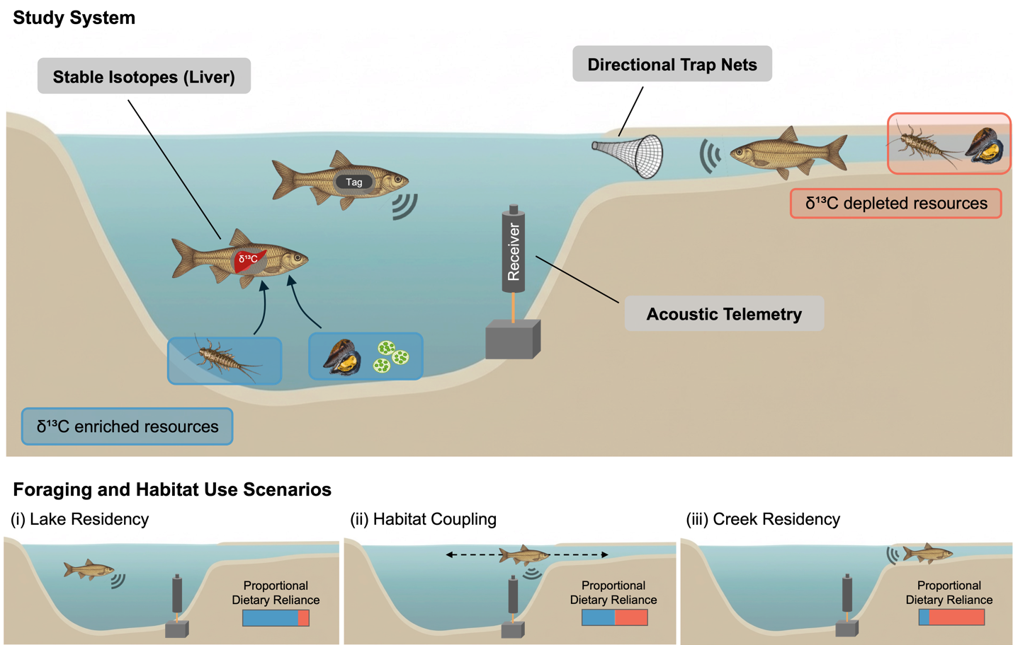
Figure 1. Conceptual diagram illustrating how stable isotope analysis, acoustic telemetry, and netting surveys are used to assess seasonal lake–creek habitat coupling by prey fish. Differences in δ¹³C between lake (enriched; blue) and creek (depleted; pink) resources (e.g., mayflies, mussels) allow stable isotope ratios in fish tissues (liver) to indicate cross-habitat foraging. Acoustic receivers continuously track the movement and residence of tagged fish across lake and creek habitats. Directional trap nets estimate seasonal biomass flux by capturing fish moving upstream and downstream in the creek. The lower panels depicts three scenarios of fish foraging and habitat use: (i) lake residency, where fish rely primarily on lake-derived resources and are detected mostly in the lake; (ii) habitat coupling, where fish rely on both lake- and creek-derived resources and show intermediate lake residency, with detections indicating movement between habitats; and (iii) creek residency, where fish rely primarily on creek-derived resources and are detected mostly in the creek. Seasonal variation in habitat coupling is expected as fish adjust movement and foraging in response to changing biotic and abiotic conditions.

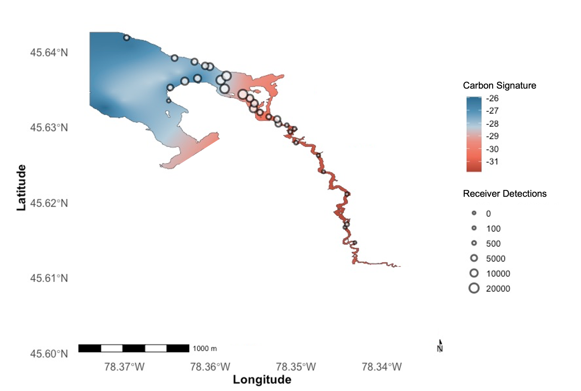
Figure 2. Site map and IsoScape of Opeongo Lake (Sproule Bay) and the adjacent Costello Creek. Baseline organism (Ephemeroptera sp. and Eliptio sp.) average carbon signatures (δ¹³C) across the study system are represented by the coloured gradient, while receiver locations and total detections at each receiver are shown as circles and their relative sizes, respectively. Areas shaded in blue indicate δ¹³C -enriched regions in the lake, while pink-shaded areas represent δ¹³C-depleted regions in the creek.

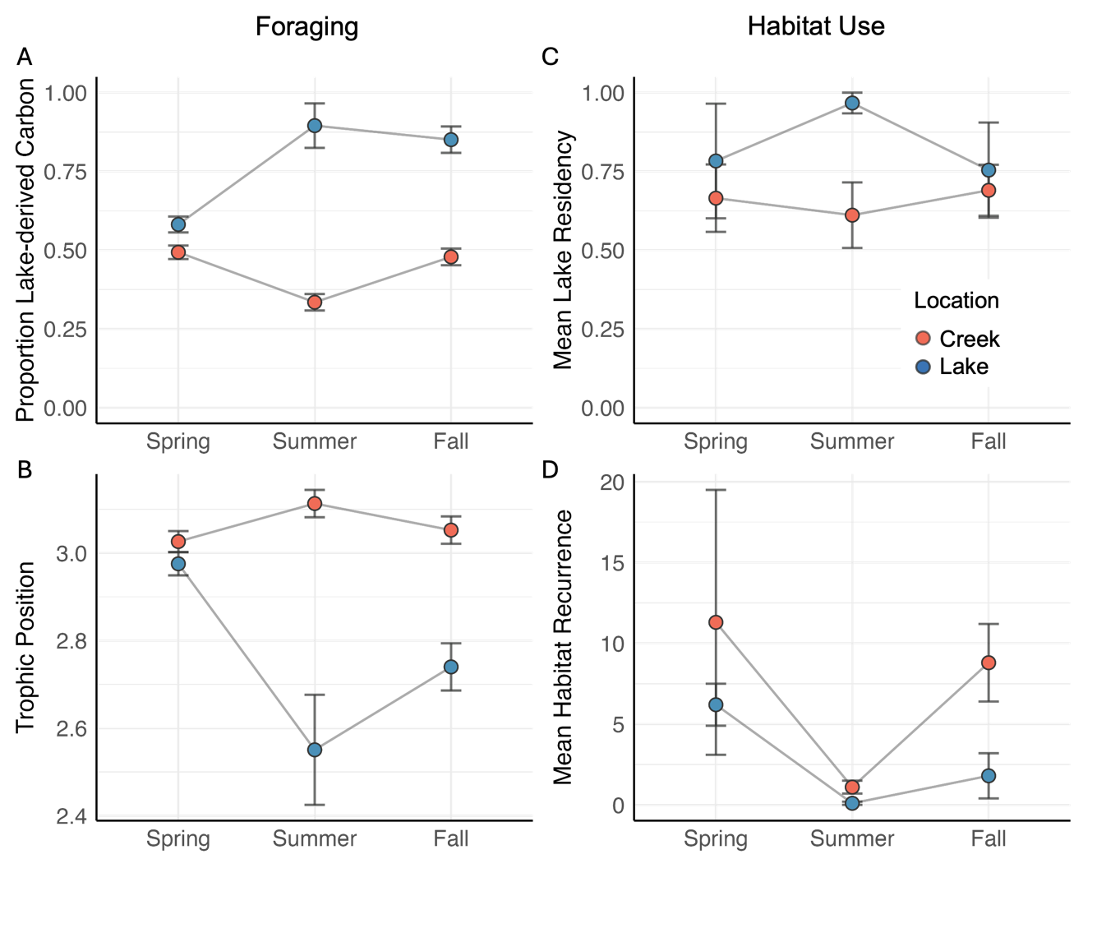
Figure 3. Seasonal foraging (left panels) and habitat use (right panels) among shiners in Costello Creek and Lake Opeongo (Sproule Bay). Mean (±SE) proportion of lake-derived carbon (A) and trophic position (B) of fish captured in the creek (pink) and lake (blue) across seasons. Mean (± SE) lake residency (C) and number of recurrence events (D) among tagged golden shiners for fish captured and released in the creek (pink) or lake (blue). Residency is calculated as the proportion of time a shiner spent in the lake per season, and recurrence is calculated as the number of times a shiner exited and re-entered the habitat in which it was released.
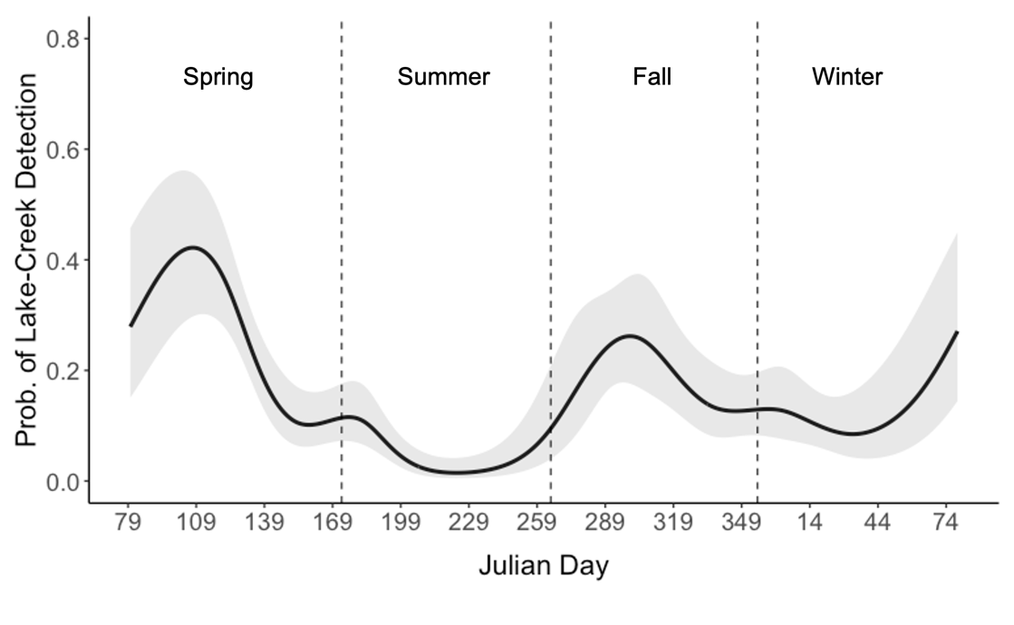
Figure 4. Predicted probability of detecting individual fish in both the lake and the creek on the same day throughout the year (black line) with 95% confidence intervals (shaded area), estimated using a generalized additive mixed model (GAMM) with a logit link function. Vertical dashed lines indicate seasonal boundaries (spring, summer, fall, winter).
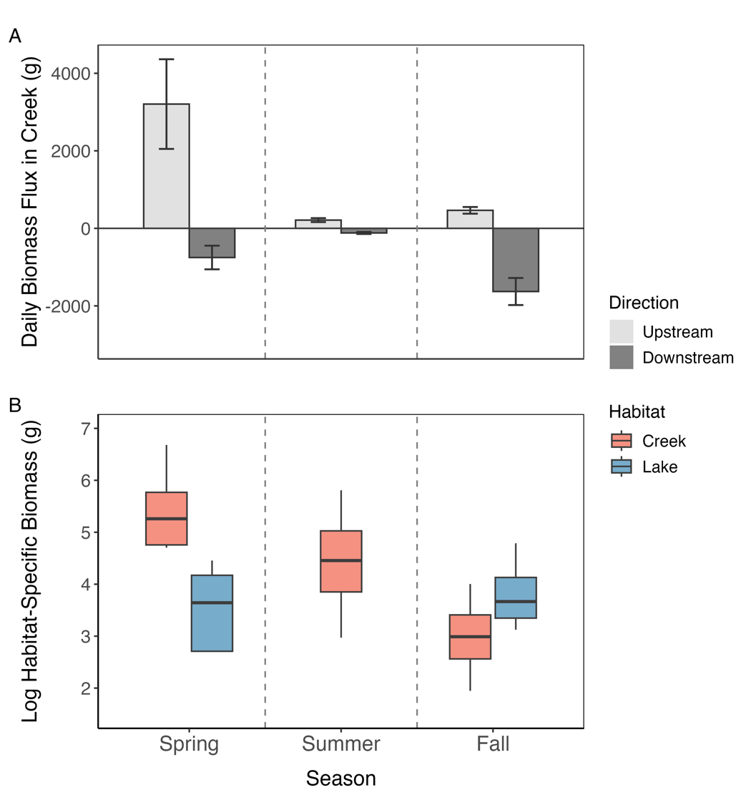
Figure 5. Biomass (g) of shiners caught in trap nets during seasonal netting surveys. (A) Mean (± SE) biomass flux of shiners captured in upstream (light grey) and downstream (dark grey) directionally positioned traps in Costello Creek per day. (B) Mean (± SE) log-transformed biomass (g) of shiners captured in minnow traps deployed in the lake (blue) and creek (pink) seasonally. Note that in the panel (A), biomass data are not log transformed to visually highlight the magnitude of difference across seasons.

